AGENDA
International Awareness-Raising and Networking Workshop
“Building a Transnational Network for Sturgeon Conservation in the Black Sea Basin”
7 April 2026, Constanța Casino
09:00 - 10:00 Registration of participants and welcome coffee
10:00 - 10:30 Opening session
10:30 - 11:30 Session I – The SturNet Project: objectives, activities and digital tools
Ina AGAFONOVA
Protection of Biodiversity Foundation
SturNet Project Overview: Objectives, Activities and Expected Results
Olha GOLIKOVA, Olha KARPENKO
State Organization “Institute of Market and Economic & Ecological Research of National Academy of Sciences of Ukraine”
Sturgeon Conservation Challenges and Perspectives in the Black Sea Region
Dimitrios PAPADOPOULOS, Ioannis GIANTSIS
Aristotle University of Thessaloniki
Genetic Analysis of Water and Sturgeon Samples from the Black Sea Basin
Gabriel IORDACHE, Roy KOUSTAV
GeoEcoMar and SafetyMed
SturNet Digital Tools: Website, Digital Mapping Tool and Mobile Application Overview
Anonymous Participant Questionnaire and Feedback Session
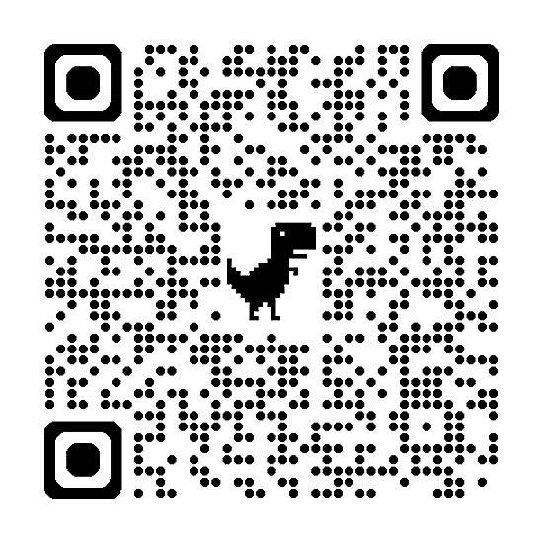
11:30 - 12:00 Coffee break
12:00 - 13:00 Session II – Special Horizon Europe MARBEFES session
13:00 - 14:00 Lunch break / Scientific poster session
14:00 - 16:00 Session III – Stakeholder session: good practices, cooperation and synergies
Cristina SANDU, Jürg BLOESCH, Marian PARASCHIV, Stefan HONT, Marian IANI, Daniela HOLOSTENCO, Mirjana LENHARDT, Marija SMEDEREVAC LALIC
International Association for Danube Research
Science without borders: over two decades of sturgeon conservation in the Danube River Basin
George CARACAS
WWF-Romania
Saving Sturgeons by Tackling By-catches and Illegal Trade and by Supporting Key Fishing Communities in Developing Alternative Income Sources (S.O.S. Romania)
Cristina MUNTEANU
WWF - România
LIFE Boat4Sturgeon project - Safeguarding the Giants of the Danube

Sabin ROTARU
National Institute of Marine Geology and Geoecology - GeoEcoMar
Habitat Mapping of Sturgeons in the Danube Basin
Victor NIȚĂ
National Institute for Marine Research and Development “Grigore Antipa”
Mapping Sturgeon Foraging Areas in the Western Black Sea: An Approach for Integrating Conservation Targets and Sustainable Management of Marine Resources
Maria Iasmina MOZA
University of Bucharest, Faculty of Biology
Tracking Climate Change Impacts in the Danube Delta: A Biodiversity Hotspot at Risk
Irina STANCIU
National Institute of Marine Geology and Geoecology - GeoEcoMar
ECOO: Enhancing Coordination and Synergies in Ocean Observations in the EU
Marian PAIU
Mare Nostrum NGO
Mare Nostrum: Upscaling Environmental Protection through Community Engagement and Capacity Building
16:00 - 16:30 Conclusions, final discussions and closing of the event

