SturNet Partners Meet in Türkiye: Fourth Transnational Project Meeting Hosted by Gebze Technical University

On 16–17 September 2026, the SturNet consortium gathered in Türkiye for its Fourth Transnational Project Meeting (TPM4), hosted by Gebze Technical University (GTU), combining a full day of project work in Gebze with a study visit to a sturgeon breeding centre in Bolu.

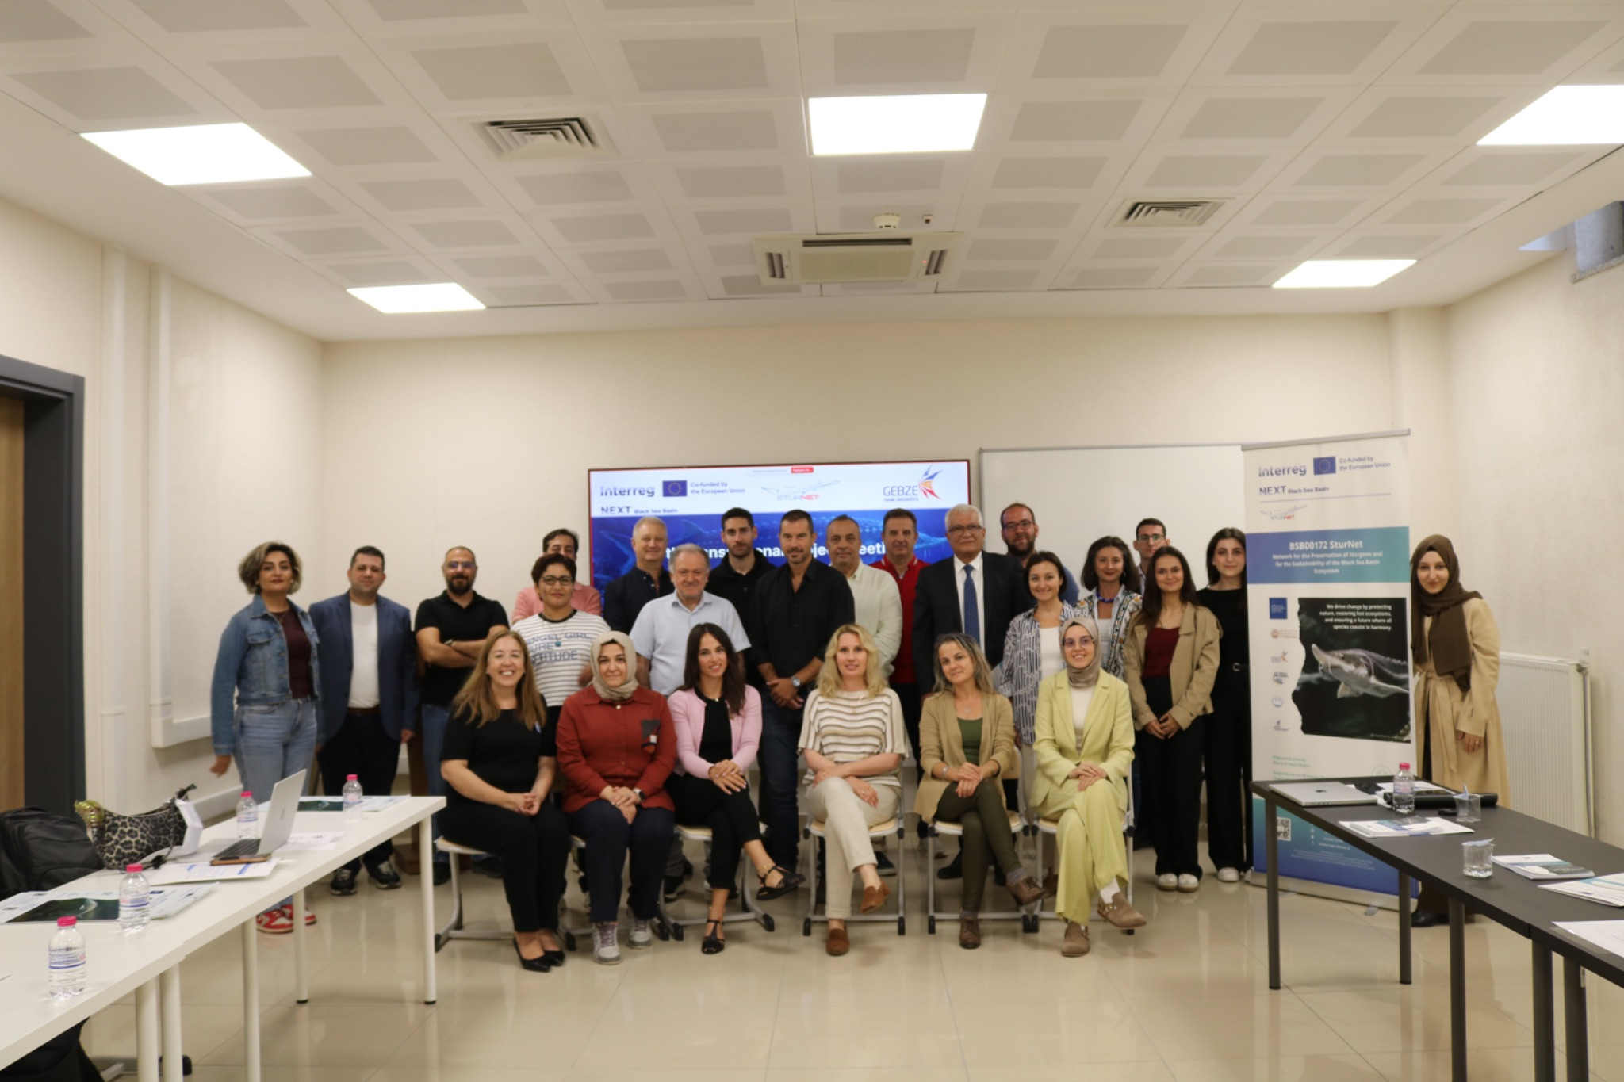
Caption: The SturNet consortium at Gebze Technical University, 16 September 2026.

The Fourth Transnational Project Meeting of the project BSB00172 "SturNet — Network for the Preservation of Sturgeon and for the Sustainability of the Black Sea Basin Ecosystem", implemented under the Interreg NEXT Black Sea Basin Programme 2021–2027 and co-funded by the European Union, took place on 16–17 September 2026 in Türkiye, hosted by project partner Gebze Technical University (PP4).

Partners travelled from across the Black Sea Basin to attend in person: the Lead Partner, Protection of Biodiversity in Bulgaria Foundation (Bulgaria), the Aristotle University of Thessaloniki (Greece), the Ecological Counseling Center Cahul (Moldova) and the National Institute for Research and Development on Marine Geology and Geo-ecology — GeoEcoMar (Romania), joining their hosts from Gebze Technical University, while colleagues from ECC Cahul and from the Institute of Market and Economic & Ecological Researches of the National Academy of Sciences of Ukraine (IMEER) also followed the working session online. The consortium was also pleased to welcome researchers from Ege University (Türkiye), whose participation reflects the continuing growth of the transnational SturNet network beyond the project partnership itself.

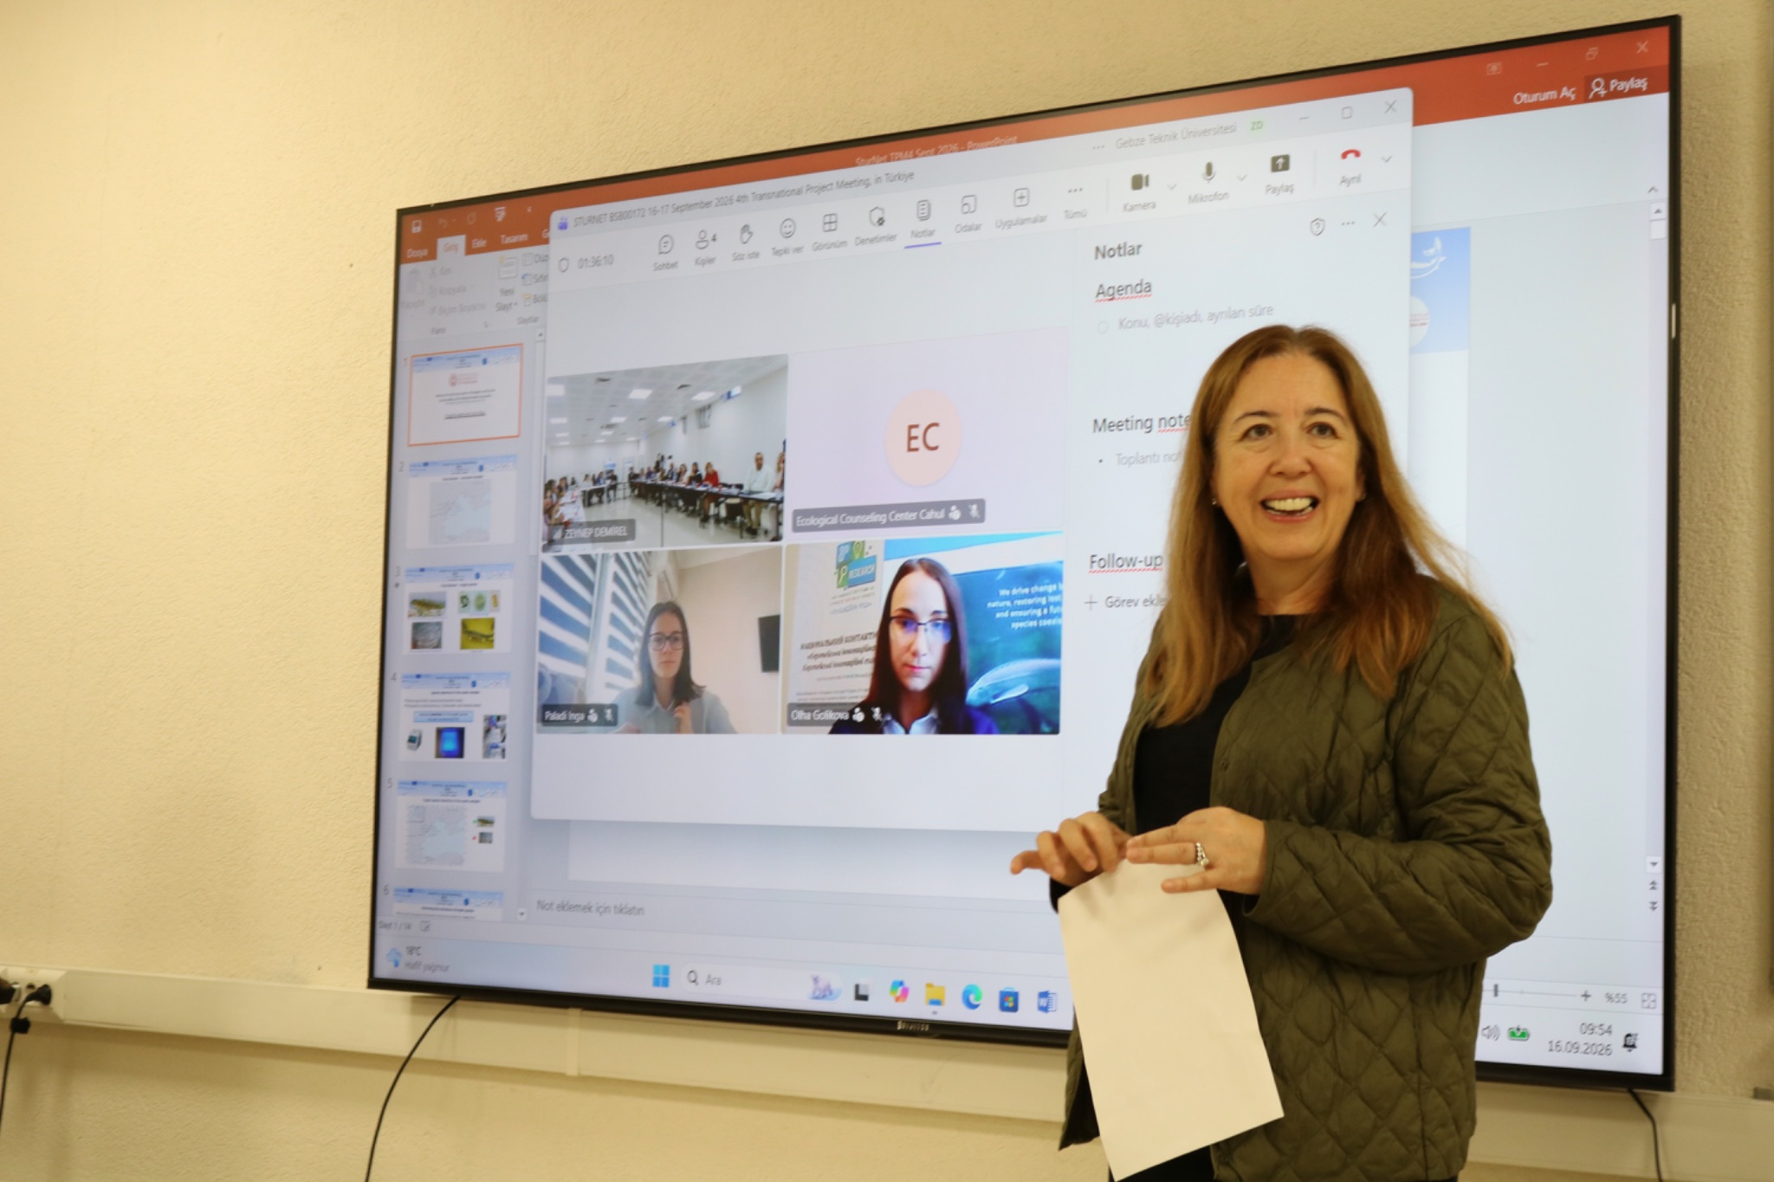
Caption: Opening of the working session at Gebze Technical University, with partners joining both in person and online.

The first day, held at the Gebze Technical University campus on 16 September, was dedicated to the joint work of the partnership. The partners reviewed the state of implementation across the project's core activities: the expansion of the Transnational Sturgeon Network, which continues to attract new member organisations through Memoranda of Cooperation across the Black Sea Basin countries, and the Digital Cooperation Tool and mobile application developed under the project, which bring together the partners' sturgeon and environmental data on a common digital platform. The consortium also coordinated the planning of the remaining implementation period, including the forthcoming awareness-raising events and the joint scientific work arising from the project's field research.

A dedicated session looked beyond the current project: the partners discussed future collaboration opportunities in the Black Sea Basin — from transnational networking and digital mapping tools to sustainable blue economy and biodiversity restoration — joined by a guest presentation from the EU and Foreign Affairs Department of the Kocaeli Governorship on regional cooperation experience and joint project perspectives.
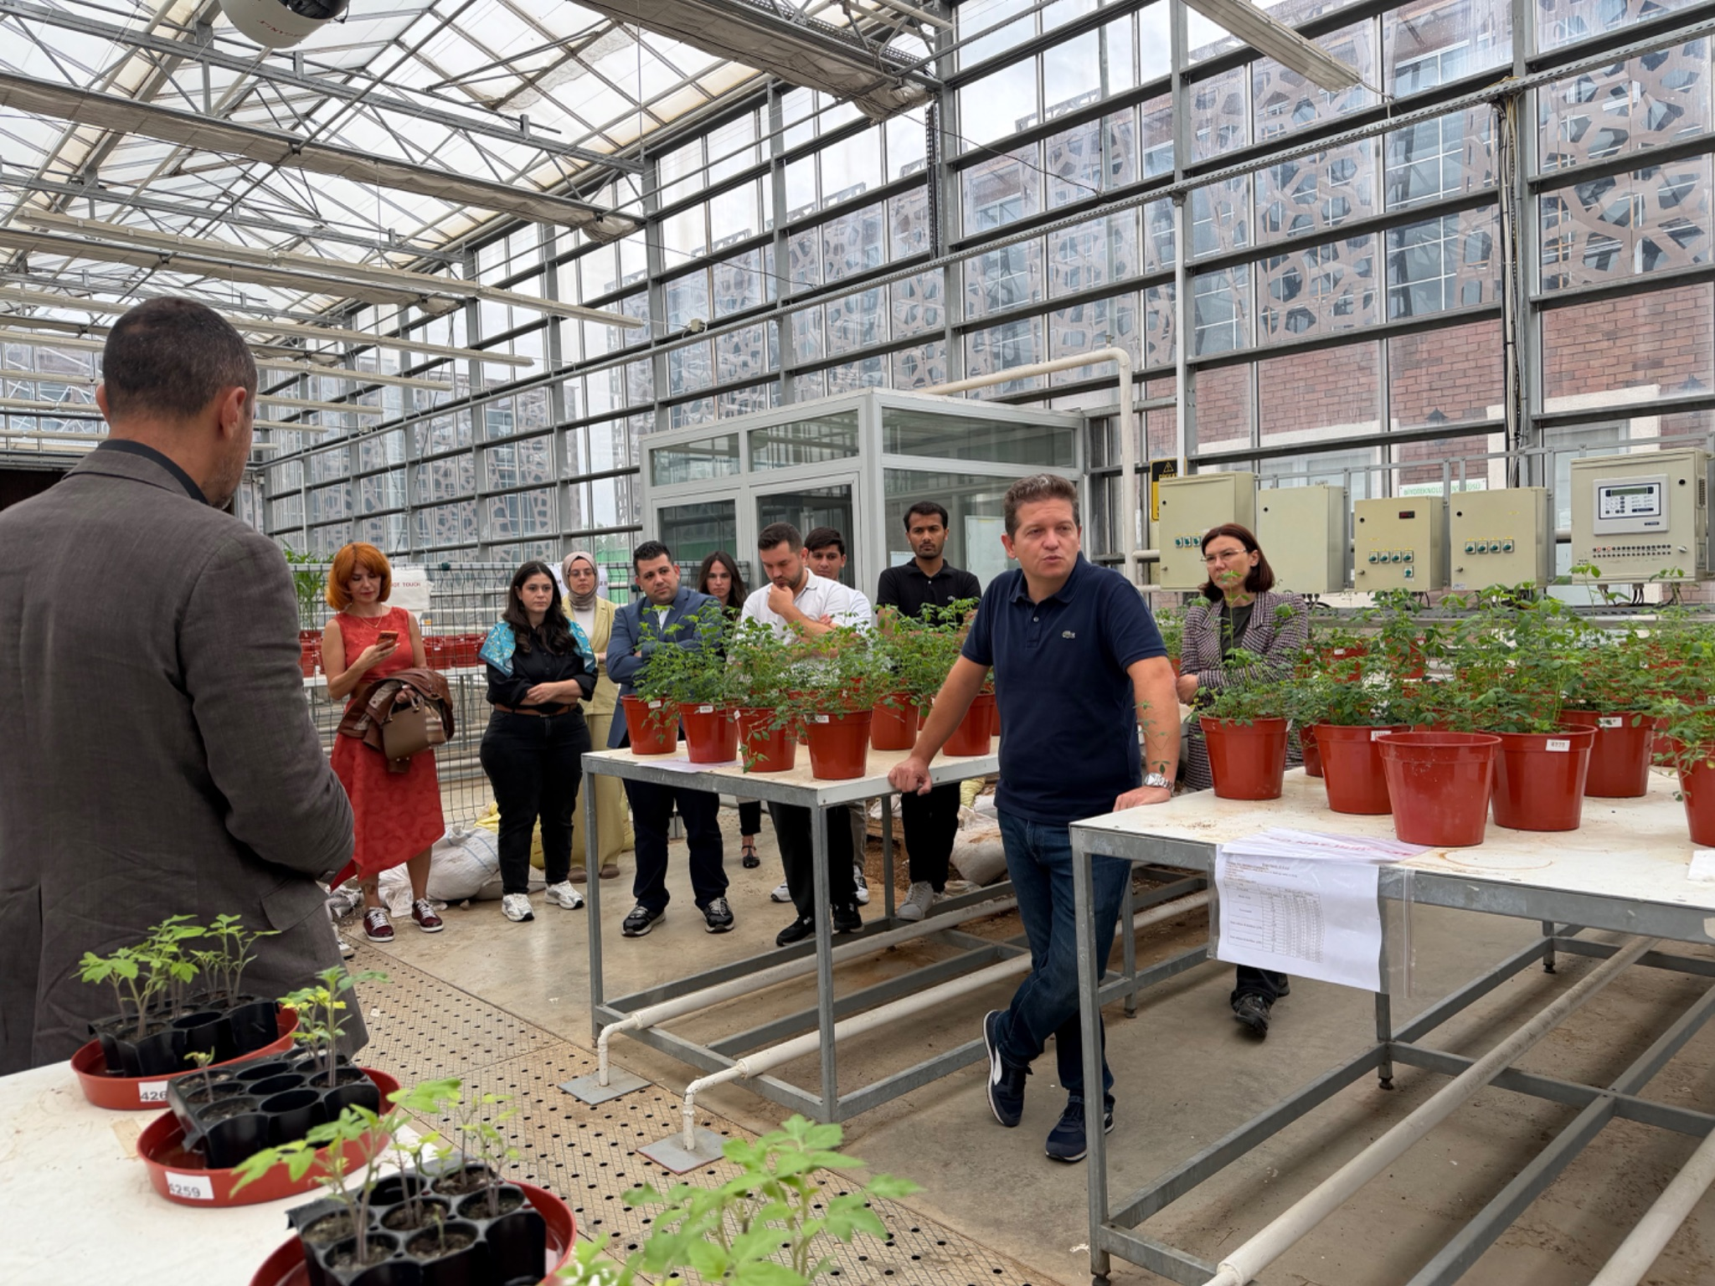

Caption: Discussing future collaboration perspectives for the SturNet network.

On 17 September, the second day of the meeting, GTU organised a study visit to a sturgeon breeding centre in Bolu (Gölköy). The visit gave the partners a first-hand view of sturgeon breeding and restoration practice in Türkiye and a valuable opportunity to exchange experience with Turkish colleagues on ex-situ conservation — a subject at the very heart of the SturNet mission of protecting these critically endangered species across the Black Sea Basin.

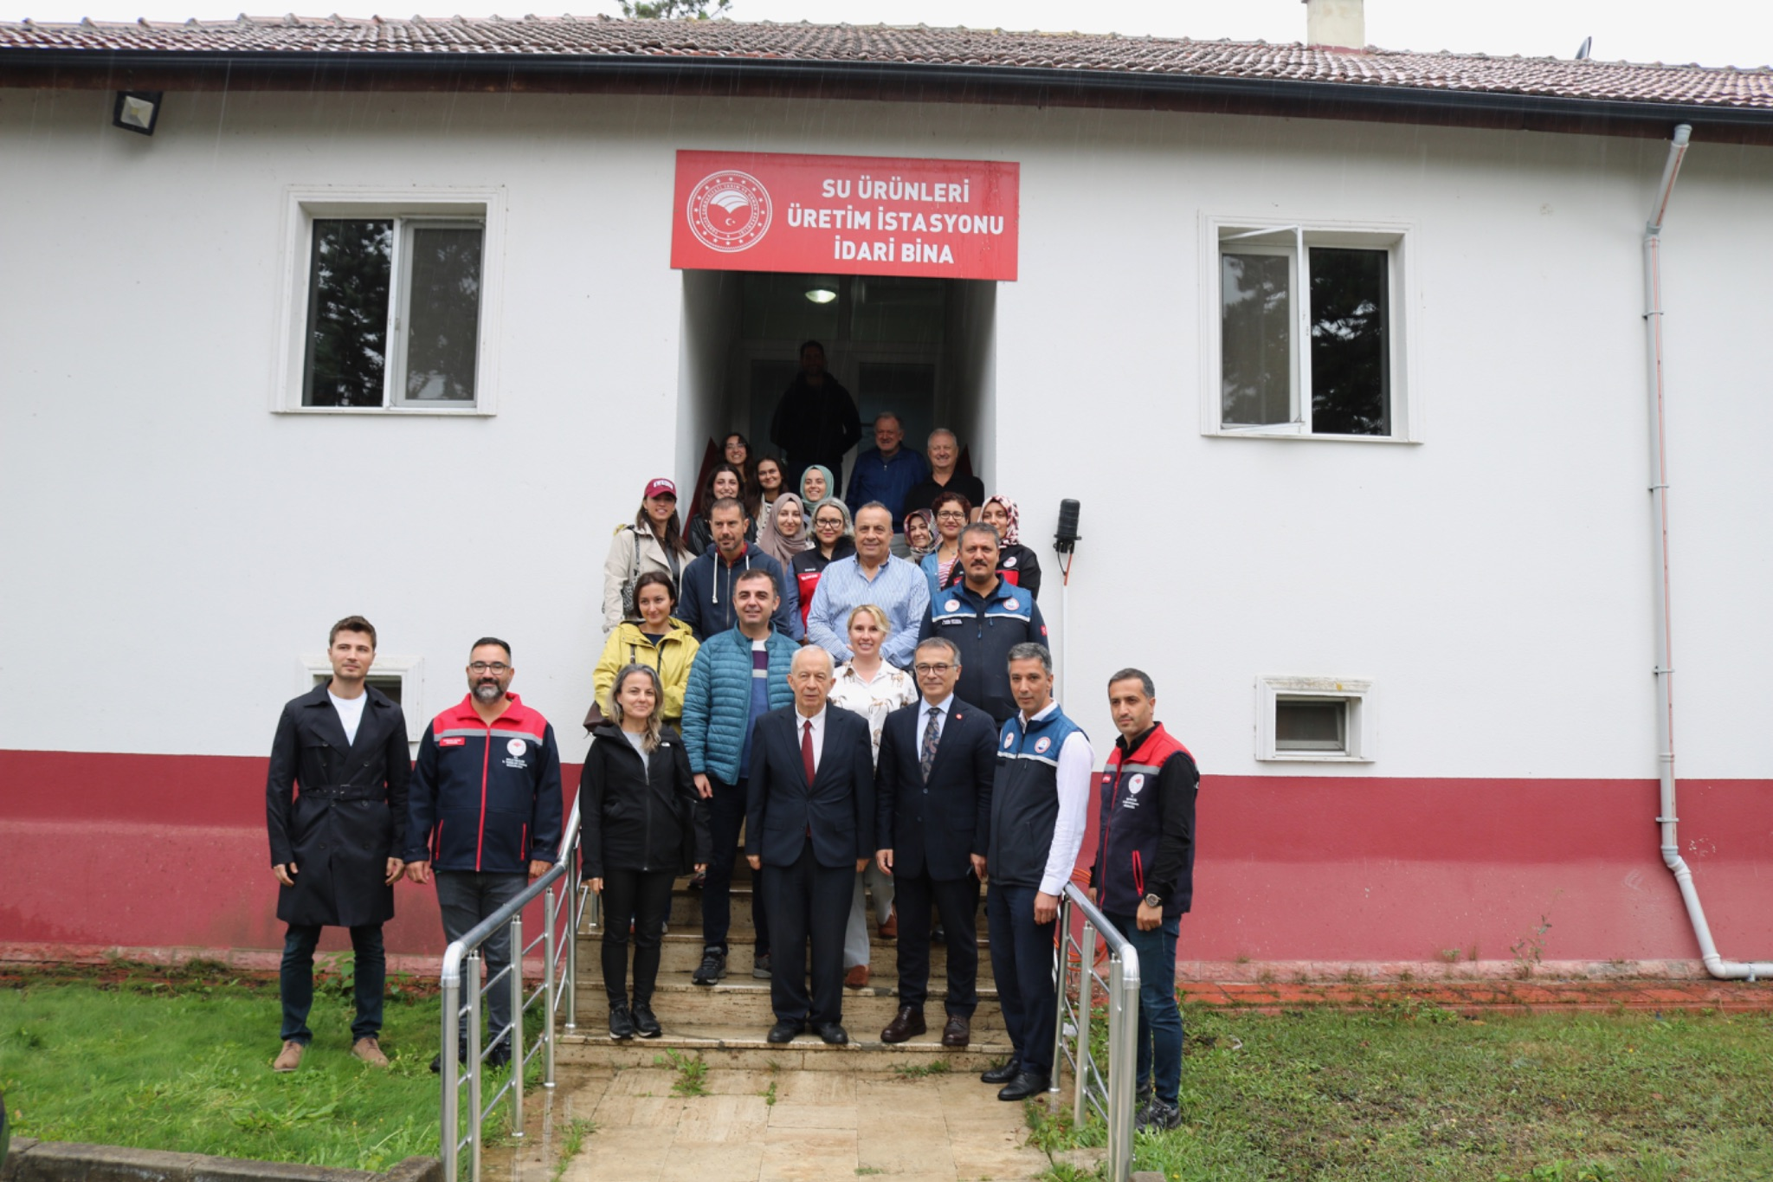
Caption: Study visit to the sturgeon breeding centre in Bolu, 17 September 2026.

The meeting in Gebze once again demonstrated the strength of the partnership built around SturNet: five partner countries working side by side with a growing network of associated organisations, united by the goal of preserving sturgeon populations and the health of the Black Sea Basin ecosystem for future generations.

The consortium warmly thanks Gebze Technical University for the excellent organisation and hospitality.

